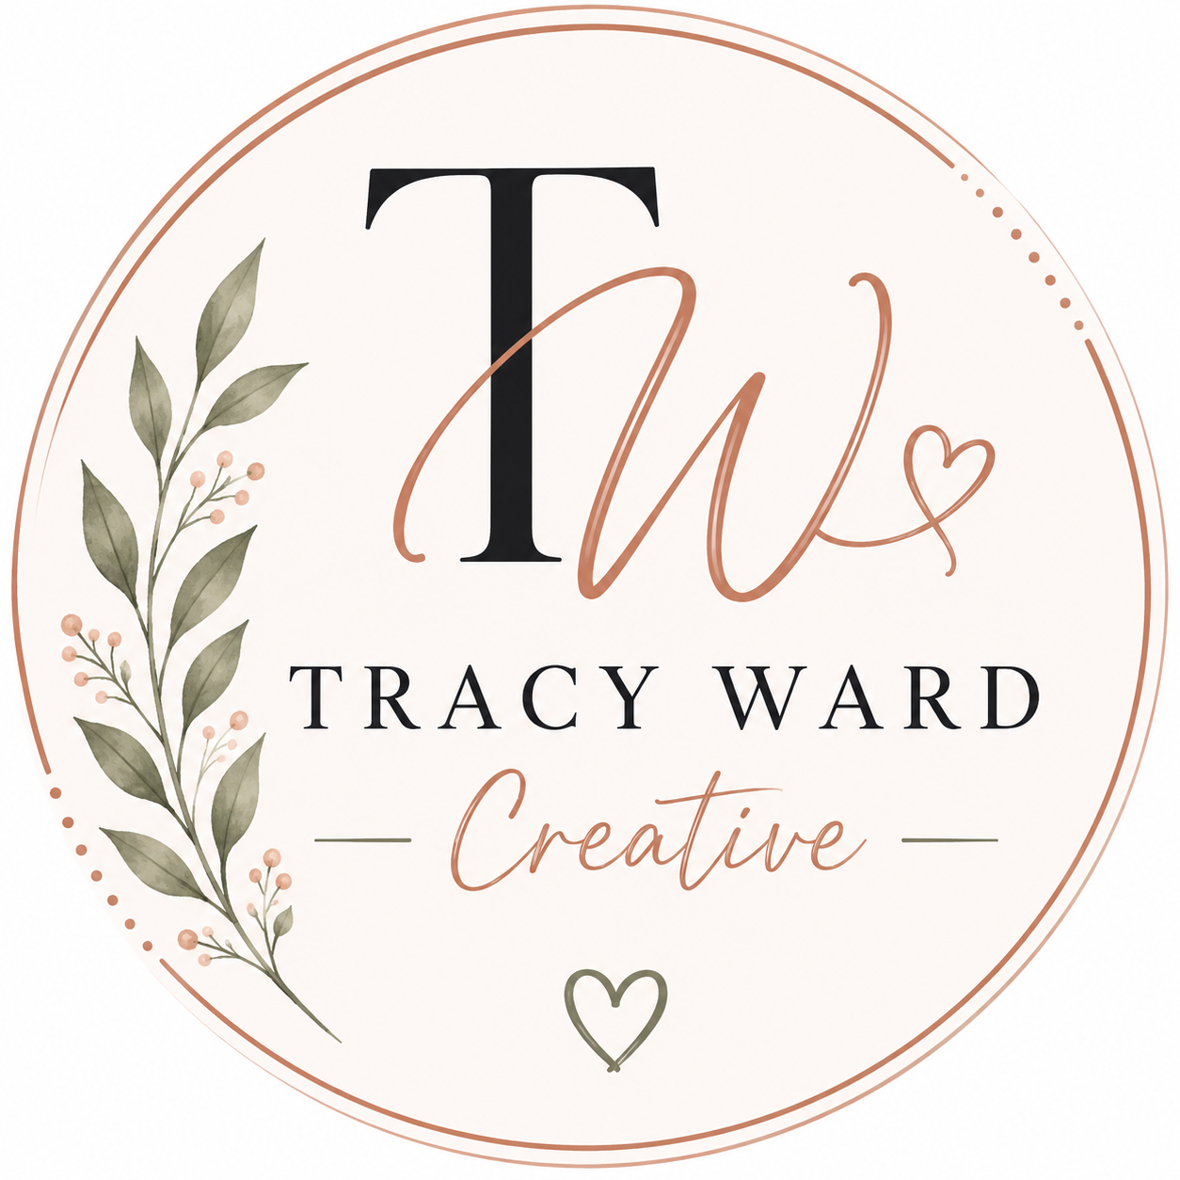
Branding Questionnaire
Tracy Ward Creative
Please complete this questionnaire to help Tracy Ward Creative better understand your brand vision, style, audience, and creative goals.

Business Information
Business Name
Business Owner / Contact Name
Phone Number
Email Address

Brand Vision & Personality
Describe your business in a few sentences
What makes your business unique?
What emotions should your brand create?
How would you describe your brand personality?
What words best describe your business?

Design & Style Preferences
Preferred brand colors
Preferred fonts or style types
What overall aesthetic fits your brand best?
Are there any colors or styles you dislike?
Do you prefer modern, rustic, bold, feminine, minimalist, playful, etc.?

Audience & Marketing
Who is your target audience?
What type of customers are you trying to attract?
What social media platforms do you currently use?
What type of content performs best for your business?

Inspiration & Additional Notes
Are there any brands/pages you love for inspiration?
Do you currently have a logo or branding?
What branding services are you interested in?
Additional notes, ideas, or requests

Thank you for trusting Tracy Ward Creative with your business branding and creative vision. 🤍

