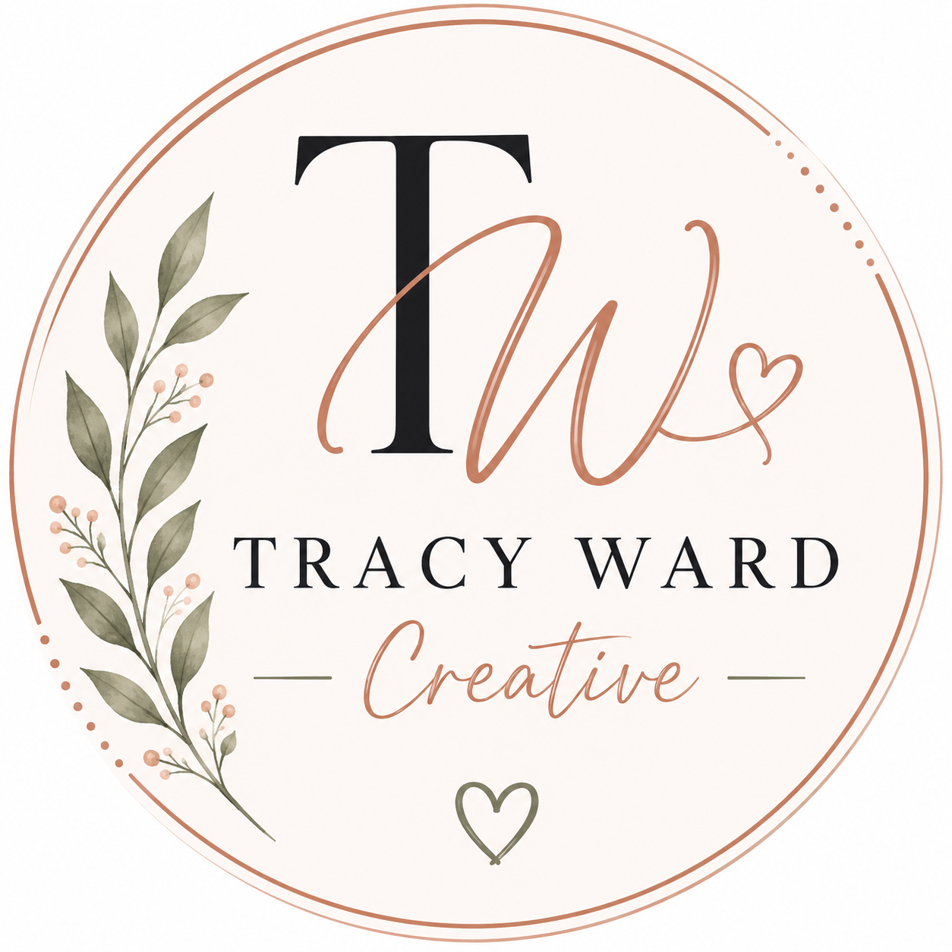
New Client Onboarding Form
Tracy Ward Creative
Please complete this form to help Tracy Ward Creative better understand your business, goals, branding, and social media needs.

Business Information
Business Name
Business Owner / Contact Name
Phone Number
Email Address
Website (if applicable)
Business Location

Social Media Information
Current Social Media Platforms
Facebook Page Name
Instagram Username
TikTok / Other Platforms
Who currently manages your social media?

Branding & Business Goals
Describe your business in a few sentences
What makes your business unique?
What are your main business goals?
What type of audience are you trying to attract?
What style best fits your brand? (modern, rustic, fun, professional, etc.)
Preferred brand colors or design styles

Content & Marketing Preferences
What type of content would you like posted?
Are there any products/services you want highlighted regularly?
Do you have upcoming events or promotions?
Would you like engagement-focused posts included?
Do you have photos/videos available for content creation?

Additional Information
Any competitors or pages you like for inspiration?
Anything you do NOT want included in your content?
Additional notes or requests

Thank you for choosing Tracy Ward Creative. We look forward to helping your business grow through authentic connection and creative content. 🤍

